**10-AMP Fuse Holder IN Nayel E-bike**

* **Revision Number:**  
  Rev. 1.0
* **Date of Creation or Update:**  
  20/10/2024
* **Prepared By:**  
  Muhammad .Sulaiman Shahid
* **Reviewed By:**
* **Approved By**

Introduction   
  
The 10-amp fuse holds significant importance in an **E-bike's electrical system**, ensuring safety, reliability, and efficient operation. Below are the key reasons it is vital:

### **Circuit Protection**

* A 10-amp fuse to safeguards the E-bike's electrical system by disconnecting the circuit if the current exceeds 10 amps.
* This prevents damage to sensitive components such as the bike IOT circuit, motor controller, or display unit.

### **Prevention of Component Overload**

* E-bikes use various components like headlights, sensors, and controllers that are designed to operate within a specific current range.
* A 10-amp fuse prevents these components from being exposed to excessive current, extending their lifespan.

### **Fire Hazard Mitigation**

* In case of wiring faults, such as frayed or damaged cables, the fuse prevents excessive current flow, reducing the risk of overheating and electrical fires.

### **Easy and Cost-Effective Maintenance**

* Fuses are inexpensive and easy to replace, providing a simple yet effective way to address electrical faults without causing significant downtime or requiring expensive repairs.

### **System Reliability**

* By isolating faults quickly, the fuse ensures that the rest of the E-bike's system remains operational, maintaining user safety and minimizing inconvenience.

### **Typical Applications in E-bikes**

* **Headlight and Taillight Circuits**: Protects the lighting system from overcurrent.
* **Controller Circuit**: Prevents damage to the motor controller during faults.
* **Charging System**: Safeguards the battery while charging.

By using a 10-amp fuse in an E-bike, manufacturers and users ensure a safe, reliable, and efficient electrical system, ultimately enhancing the overall performance and durability of the E-bike.

**Purpose of changing fuse holder**

**Mounting**: It seems to lack a mounting mechanism, making it prone to movement or vibration, which can loosen the connections over time. This losing problem was occurs in bike while it was given to ORKO for Demo/test ride.

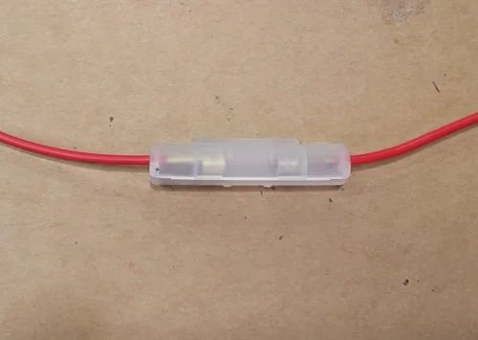

This problem of losing has been overcome with below given 10-amp fuse holder

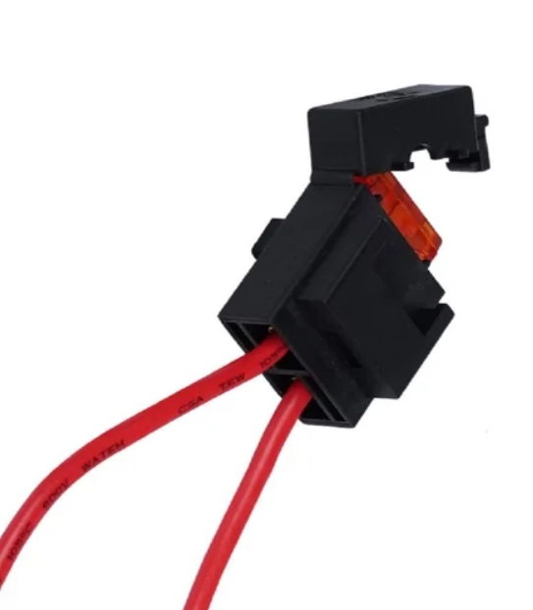**Secure Fuse Housing**: The clip-on design ensures that the fuse remains securely in place, reducing the risk of loose connections due to vibrations or movement.